Superposition

4.13 Main Question (สำหรับแสดงข้อสอบ)

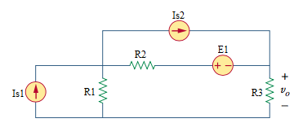

Given *E*1 = 12 V, *I*s1 = 2 A, *I*s2 = 4 A, *R*1 = 10 Ω, *R*2 = 8 Ω, *R*3 = 5 Ω.

Find

voltage *V* due to voltage source *E*1 = {#1}

voltage *V* due to current source *I*s1 = {#2}

voltage *V* due to current source *I*s2 = {#3}

voltage *V* = {#4}

Variables (สำหรับเขียนโค้ดเพื่อหาคำตอบ)

Random variables

E1 = {1:20}; IS1 = {1:20}; IS2 = {1:20};

R1 = {1:10}; R2 = {1:10}; R3 = {1:10};

Global variables

# E1 = 12; IS1 = 2; IS2 = 4; R1 = 10; R2 = 8; R3 = 5;

VE1 = -E1*R3/(R1+R2+R3);

VIS1 = IS1*R3*R1/(R1+R2+R3);

VIS2 = IS2*R3*R2/(R1+R2+R3);

Part (กรอกคำตอบ)

1. VE1 = -2.6087 V

2. VIS1 = 4.3478 V

3. VIS2 = 6.9565 V

4. V = VE1+VIS1+VIS2 = 8.696 V

Superposition

4.14 Main Question (สำหรับแสดงข้อสอบ)

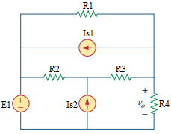

Given *E*1 = 20 V, *I*s1 = 2 A, *I*s2 = 1 A, *R*1 = 6 Ω, *R*2 = 4 Ω, *R*3 = 2 Ω, *R*4 = 3 Ω.

Find

voltage *V* due to voltage source *E*1 = {#1}

voltage *V* due to current source *I*s1 = {#2}

voltage *V* due to current source *I*s2 = {#3}

voltage *V* = {#4}

Variables (สำหรับเขียนโค้ดเพื่อหาคำตอบ)

Random variables

E1 = {1:20}; IS1 = {1:20}; IS2 = {1:20};

R1 = {1:10}; R2 = {1:10}; R3 = {1:10}; R4 = {1:10};

Global variables

# E1 = 20; IS1 = 2; IS2 = 1; R1 = 6; R2 = 4; R3 = 2; R4 = 3;

VE1 = E1*R4/(R4+ R1*(R2+R3)/(R1+R2+R3));

VIS1 = R4*(-IS1*(R1*(R2+R3)/(R1+R2+R3))/((R1*(R2+R3)/(R1+R2+R3))+R4));

VIS2 = IS2*R2*(R1*R4/(R1+R4))/((R1*R4/(R1+R4))+R2+R3);

Part (กรอกคำตอบ)

1. VE1 = 10 V

2. VIS1 = -3 V

3. VIS2 = 1 V

4. V = VE1+VIS1+VIS2 = 8 V

Superposition

4.15 Main Question (สำหรับแสดงข้อสอบ)

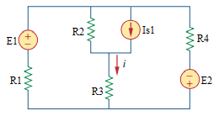

Given *E*1 = 20 V, *E*2 = 16 V, *I*s1 = 2 A, *R*1 = 2 Ω, *R*2 = 1 Ω, *R*3 = 3 Ω, *R*4 = 4 Ω.

Find

current *I* due to voltage source *E*1 = {#1}

current *I* due to voltage source *E*2 = {#2}

current *I* due to current source *I*s1 = {#3}

current *I* = {#4}

Variables (สำหรับเขียนโค้ดเพื่อหาคำตอบ)

Random variables

E1 = {1:20}; E2 = {1:20}; IS1 = {1:20};

R1 = {1:10}; R2 = {1:10}; R3 = {1:10}; R4 = {1:10};

Global variables

#E1 = 20; E2 = 16; IS1 = 2; R1 = 2; R2 = 1; R3 = 3; R4 = 4;

IE1 = E1/((R4*(R2+R3)/(R2+R3+R4))+R1)*(R4/(R2+R3+R4));

IE2 = -E2*((R1*(R2+R3)/(R1+R2+R3))/((R1*(R2+R3)/(R1+R2+R3))+R4))/(R2+R3);

IIS1 = IS1*(R2/(R2+R3+(R1*R4/(R1+R4))));

Part (กรอกคำตอบ)

1. IE1 = 2.5 A

2. IE2 = -1 A

3. IIS1 = 0.375 A

4. I = IE1+IE2+IIS1 = 1.875 A

Superposition

4.18 Main Question (สำหรับแสดงข้อสอบ)

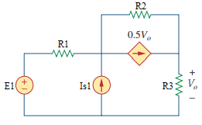

Given *E*1 = 10 V, *I*s1 = 2 A, *R*1 = 2 Ω, *R*2 = 1 Ω, *R*3 = 4 Ω.

Find

voltage *V* due to voltage source *E*1 = {#1}

voltage *V* due to current source *I*s1 = {#2}

voltage *V* = {#3}

Variables (สำหรับเขียนโค้ดเพื่อหาคำตอบ)

Random variables

E1 = {1:10}; IS1 = {1:10};

R1 = {1:10}; R2 = {1:10}; R3 = {1:10};

Global variables

#E1 = 10; IS1 = 2; R1 = 2; R2 = 1; R3 = 4;

VE1 = R3*(E1/(R1+R2+0.5*R3));

VIS1 = R3*(IS1*R1/(R1+R2+0.5*R3));

Part (กรอกคำตอบ)

1. VE1 = 8 V

2. VIS1 = 3.2 V

3. V = VE1+VIS1 = 11.2 V

Superposition

4.19 Main Question (สำหรับแสดงข้อสอบ)

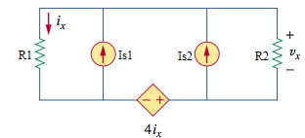

Given *I*s1 = 6 A, *I*s2 = 4 A, *R*1 = 2 Ω, *R*2 = 8 Ω.

Find

voltage *V* due to current source *I*s1 = {#1}

voltage *V* due to current source *I*s2 = {#2}

voltage *V* = {#3}

Variables (สำหรับเขียนโค้ดเพื่อหาคำตอบ)

Random variables

IS1 = {1:10}; IS2 = {1:10};

R1 = {1:10}; R2 = {1:10};

Global variables

#IS1 = 6; IS2 = 4; R1 = 2; R2 = 8;

VIS1 = IS1/(1/R1+1/R2+4/(R1^2-4*R1));

VIS2 = IS2/(1/R1+1/R2+4/(R1^2-4*R1));

Part (กรอกคำตอบ)

1. VIS1 = -16 V

2. VIS2 = -10.667 V

3. V = VIS1+VIS2 = -26.67 V